

Faculty Of Engineering
Fundamentals Of Software Development
Laboratory Manual

NAME: …………………………………………………………………………………………………………
ENROLLMENT NUMBER: ………………………………………………………………………….
SUBJECT NAME: ……………………………………………………………………………………….
SUBJECT CODE: ………………………………… BRANCH: ……………………………………
SEMESTER: ……………………… ACADEMIC YEAR: ………………………………………

s

ISBN Number -
Swaminarayan university
Publication


Certificate

This is to certify that Mr. / Ms. / Mrs. …………………………….……………………………… having enrollment number ……………………………………… of ….............. Semester ME / BE / DIPLOMA in ………….……….……….………..……….. has satisfactorily completed his term working (Subject name ……………………………………......) (subject code: ………….) during academic year ………….... at Faculty of Engineering, Swaminarayan University.

Place: ……………….
Date: ….....................

Sonal Prajapati Dr.Bhavana Soni
SUBJECT IN-CHARGE HOD DEAN

List of Practicals

Sr. No. | Title | Page No. | Date | Sign
¹ | Identify the development model for software with proper explanation. | 3
² | Gather requirement for software. | 6
³ | Prepare SRS Document for Software. | 8
⁴ | Design Activity Diagram for system. | 10
⁵ | Design Use-case Diagram for system. | 11
⁶ | Design Data Dictionary of system. | 14
⁷ | Prepare E-R Diagram of System. | 15
⁸ | Design Data Flow Diagram of system | 16
⁹ | Prepare Gantt chart of system. | 18
¹⁰ | Prepare suitable test case for system testing | 19

PRACTICAL 1

AIM: Identify the development model for software with proper explanation.

Find the sum of two given numbers.

Development Models for Software

A Software Development Model is a structured approach used by developers to plan, design, develop, test, and maintain software. It defines the steps and processes followed during software development. Different software projects use different development models depending on requirements, time, and acomplexity.

1. Waterfall ModelDefinition
The Waterfall Model is a traditional software development model where development happens in a fixed sequence of stages. Each stage must be completed before moving to the next one.

Phases:
- Requirement Analysis – Collect and understand user needs.
- System Design – Create software design.
- Implementation – Write the program code.
- Testing – Find and fix errors.
- Deployment – Release the software.
- Maintenance – Update and support the software.

Example
Building a house: First create a plan, then construct it, then decorate it. You cannot easily change the design after construction begins.

Advantages
- Simple and easy to understand.
- Clear project structure.
- Good for projects with fixed requirements.

Disadvantages
- Difficult to make changes later.
- Testing happens late.
- Not suitable for changing requirements.

2. Agile Model

Definition
The Agile Model is an iterative development approach where software is developed in small parts (iterations) with continuous feedback from users.

How It Works:
- Project is divided into small tasks called sprints.
- Developers build and test each part.
- Users provide feedback.
- Improvements are made continuously.

Example
Developing a mobile app by releasing basic features first and adding new features in later updates.

Advantages
- Flexible and allows changes.
- Faster delivery.
- Better customer involvement.

Disadvantages
- Requires regular communication.
- Difficult to predict final cost and time.

3. Spiral Model

Definition
The Spiral Model combines development with risk analysis. Software is developed through repeated cycles (spirals).

Main Activities:
- Planning
- Risk analysis
- Development
- Testing and evaluation

Example
Used for large projects like banking systems where security and risks must be carefully managed.

Advantages
- Good risk management.
- Suitable for large and complex projects.
- Allows changes.

Disadvantages
- Expensive.
- Requires expert management.

4. Prototype Model

Definition
The Prototype Model creates an early sample version of software to understand user requirements before developing the final product.

Example
Creating a sample design of a website and showing it to users before building the complete website.

Advantages
- Helps understand user needs.
- Reduces misunderstandings.
- Improves final software quality.

Disadvantages
- Users may expect the prototype as the final product.
- Extra development time may be required.

PRACTICAL 2

AIM: Gather requirement for software.

Gather Requirements for Software

Project: Online Library Management System

1. Introduction
An Online Library Management System is a software application used to manage library activities such as adding books, managing students, issuing books, returning books, and maintaining records. The purpose of this project is to make library operations faster, easier, and more organized.

2. Requirement Gathering
Requirement gathering is the process of collecting information about what users need from the software. It helps developers understand the features and functions required for the project.

Methods Used for Gathering Requirements
- Interviews – Discussing with librarians and students to understand their needs.
- Questionnaires – Collecting feedback from users.
- Observation – Studying the existing library process.
- Document Analysis – Reviewing existing records and reports.
3. Functional Requirements
Functional requirements describe what the software should do.

Admin/Librarian Functions
- Login to the system securely.
- Add, update, and delete book information.
- Manage student/member records.
- Issue books to students.
- Accept returned books.
- Search for books.
- Generate reports of issued and available books.

Student/User Functions
- Register and log in.
- Search available books.
- View issued books.
- Check return dates.
- Receive notifications about due dates.
4. Non-Functional Requirements

Non-functional requirements describe how the software should perform.
- Security: User data should be protected with authentication.
- Performance: The system should respond quickly.
- Reliability: The system should work without frequent failures.
- Usability: The interface should be simple and easy to use.
- Scalability: The system should support more users and books in the future.
5. Hardware Requirements
- Computer/Server
- Minimum 4 GB RAM
- Hard disk storage
- Internet connection
6. Software Requirements
- Operating System: Windows/Linux
- Database: MySQL
- Front-end: HTML, CSS, JavaScript
- Back-end: Java/Python/PHP
7. Users of the System
- Administrator: Manages the complete system.
- Librarian: Manages books and transactions.
- Students: Search and borrow books.

PRACTICAL 3

AIM: Software Requirement Specification (SRS) Document.

Software Requirement Specification (SRS) – Online Library Management System

Intended Users:
- Administrator: Manages users and settings
- Librarian: Manages books and transactions
- Student: Searches and borrows books

Overall Description
Product Perspective:
A web-based application that replaces manual library management.
Features:
- User login
- Book management
- Student management
- Book issue/return
- Book search
- Fine calculation
- Report generation

Functional Requirements
- Secure user login
- Add, update, delete, and view books
- Manage student records
- Issue and return books with fine calculation
- Search books by name, author, category, or ID
- Generate reports

Non-Functional Requirements
- Security: Authorized access only
- Performance: Fast response and multi-user support
- Reliability: Stable system with data backup
- Usability: Simple and user-friendly interface
- Maintainability: Easy to update and maintain

Hardware Requirements
- Server: Intel i3+, 4 GB RAM, 100 GB storage
- Client: Computer, internet connection, web browser

Software Requirements
- OS: Windows/Linux
- Front-end: HTML, CSS, JavaScript
- Back-end: Java/Python/PHP
- Database: MySQL
- Web Server: Apache/Tomcat

System Constraints
- Valid user login required
- Database connection required
- Only authorized users can modify records
- Regular data backup

Database Requirements
- User: ID, Name, Username, Password, Role
- Book: ID, Name, Author, Category, Status
- Student: ID, Name, Contact
- Transaction: ID, Book ID, Student ID, Issue Date, Return Date, Fine

PRACTICAL 4

AIM: Design Activity Diagram for system.

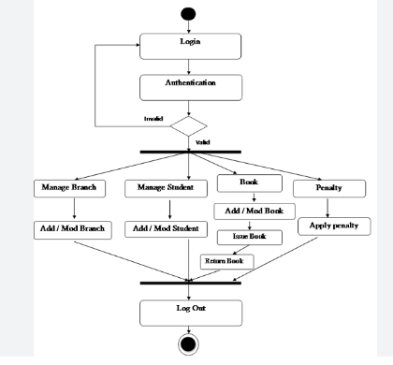

PRACTICAL 5

AIM: Design Use-case Diagram for system.

Use Case Notations

Name | Notation |  |  | Description
System boundary |  | System |  | The scope of a system can be represented by a system boundary. The use cases of the system are placed in side the system boundary, while the actors who interact with the system are put outside the system. The use cases in the system make up the total  Requirements of the system.
Use case | UseCase1 |  |  | A use case represents a user goal that can be achieved by accessing the system or software application.
Actor | Actor |  |  | Actors are the entities that interact with a system. Although in most cases, actors are used to represent the users of system, actors can actually be anything that needs to exchange information with the system. So an actor may be people, computer hardware, other systems, etc. Note that actor represent a role that a user can play,  But not a specific user.
Association |  |  |  | Actorandusecasecanbeassociatedtoindicatethattheactorparticipates in that use case. Therefore, an association corresponds to a sequence of actions between the actor and use  Case in achieving the use case.
Generalizatio n |  |  |  | A generalization relationship is used to represent inheritance relationship between model elements of same type.
Include | <<include>> |  |  | An include relationship specifies how the behavior for the inclusion use case is inserted in to the behavior defined for the base use case.
Extends | <<Extends>> |  |  | An extend relationship specifies show the behavior of the extension  use case can be inserted into the behavior defined for the base use case.
Constraint | {condition} |  |  | Show condition exists between actors an activity.
Interface | Interface |  |  | Interface is used to connect package and use-case. Head is linked  With package and tail linked with use-case.
Anchor |  |  |  | Anchor is used to connect a note the use case in use case diagram

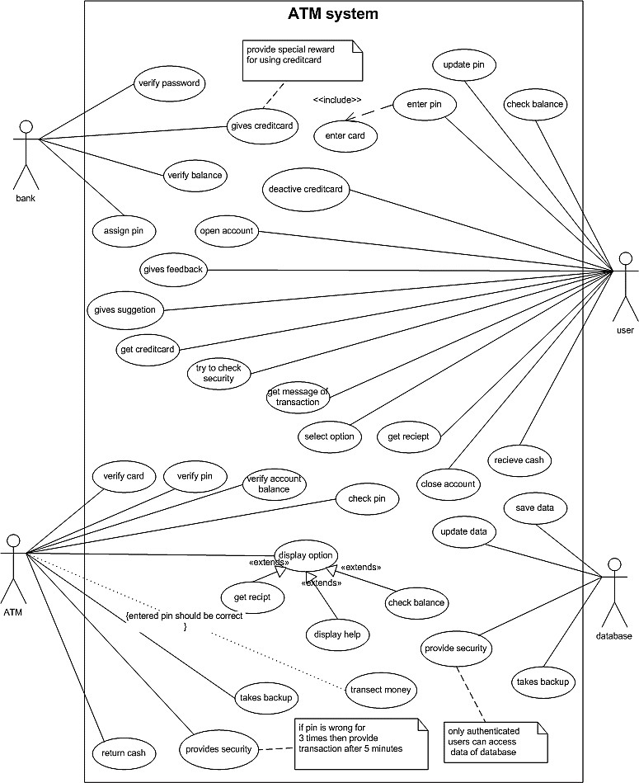

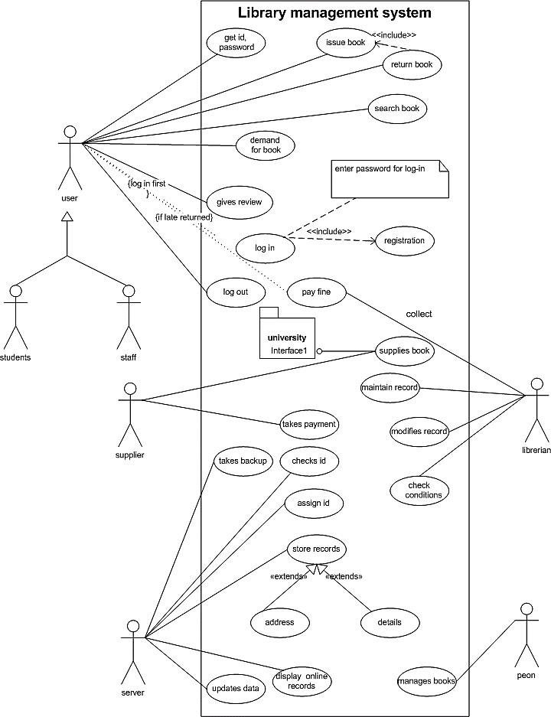

PRACTICAL 6

AIM: Design Data Dictionary of system.

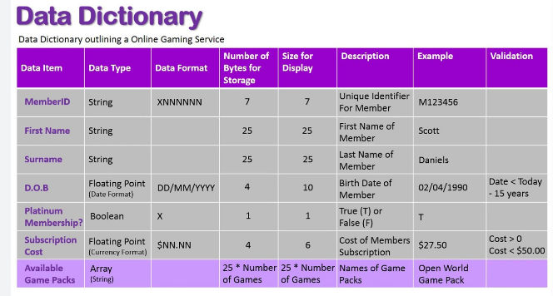

PRACTICAL 7

AIM: Prepare E-R Diagram of System.

ER Diagram for University Examination
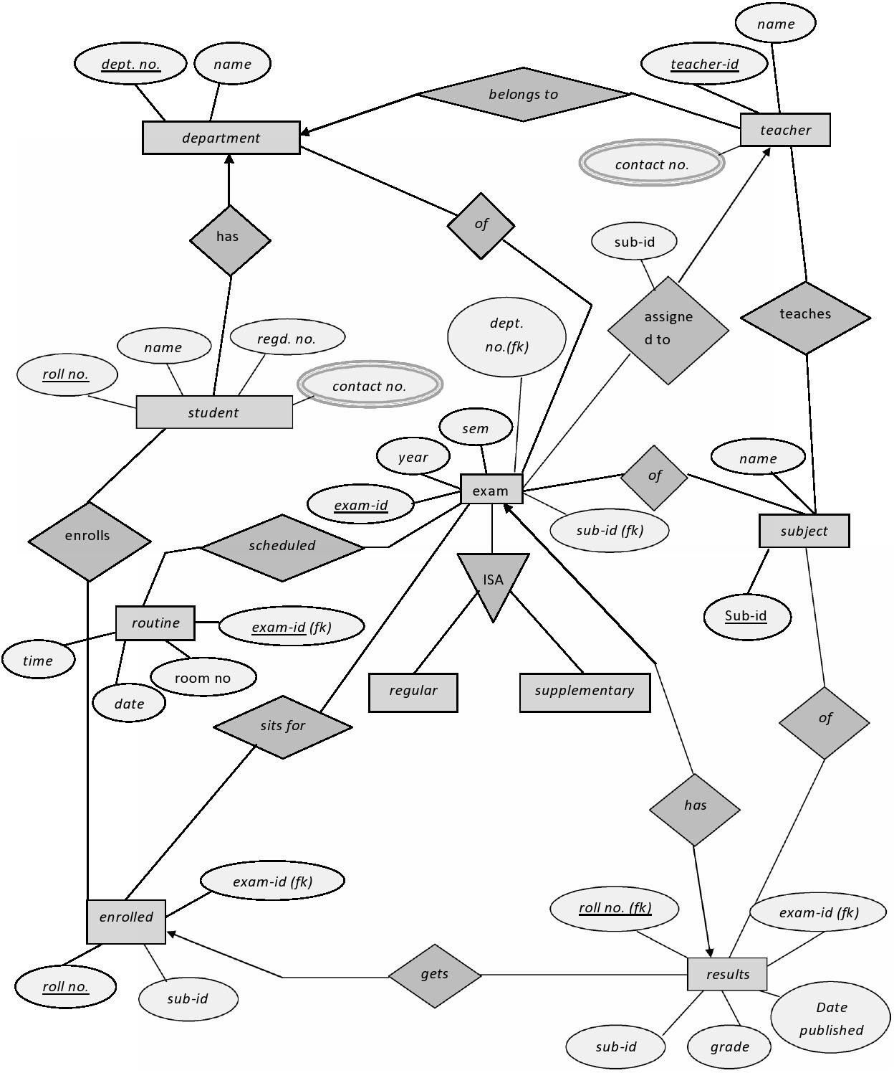

PRACTICAL 8

AIM: Design Data Flow Diagram of system

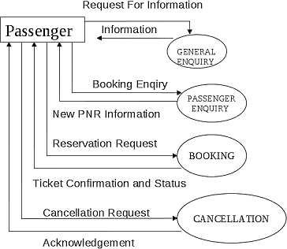
Context diagram /Level0DFD

Level1DFD
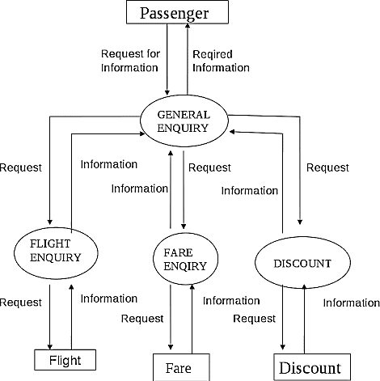

Level2DFD
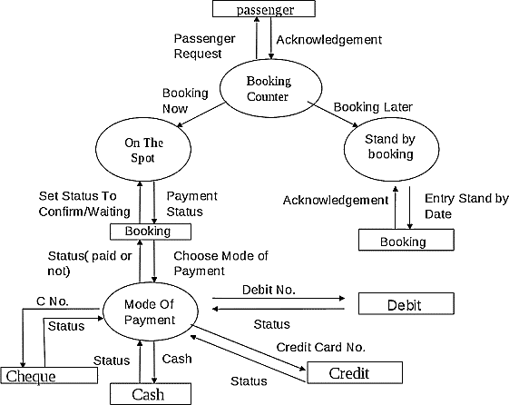

PRACTICAL 9

AIM: Prepare Gantt chart of system.

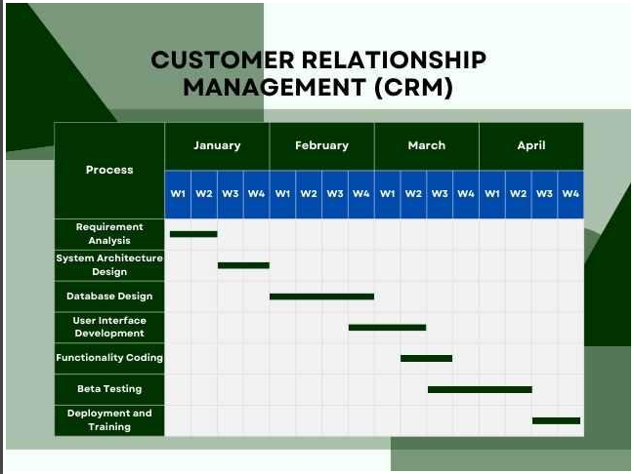

PRACTICAL 10

AIM: Prepare suitable test case for system testing
